CSC 520

Python Programming





## Project Supervisor - Professor Faramarz Mortezale

**Team Members:**

| **Name** | **Student ID** |
| --- | --- |
| Savita Khadse | 27565948 |
| Samee Peerzade | *59638609* |
| Pujitha Sai Paruchuri | 79072867 |

**TABLE OF CONTENTS**

1. Introduction
2. Technical brief
3. Game Loop
4. Tkinter- Login/Register
5. Main Game body
6. Source Code
7. Conclusion
8. Screenshots of game

**INTRODUCTION**

# What Is Wordle and How to Play?

“Wordle” is a game where the player tries to guess a dictionary word based on the hints that will be provided to the player in Wordle.

Once the player guesses the word, the input letters will be reflected as yellow,gray or green tiles. For example, a **green tile** means that the player predicted the correct placement of a letter in the correct word. A **yellow tile** means that the letter is present in the correct word, but the letter is in the wrong position. The **gray tile** means a letter does not exist in the correct word.

**Technical brief:**

Wordle game is created with object oriented programming (OOP) concepts and it includes two classes, multiple functions and imported standard packages and libraries such as tkinter.

Programming languages like Python need a special driver before they can speak to a database from a specific vendor. A database driver is a piece of software that allows an application to connect and interact with a database system.

Login pages are important for the development of any kind of mobile or web application. This page is most essential for user authentication purposes.We have also used python to MySql database connection to save users data (username, password and email id) to

**Game Loop**

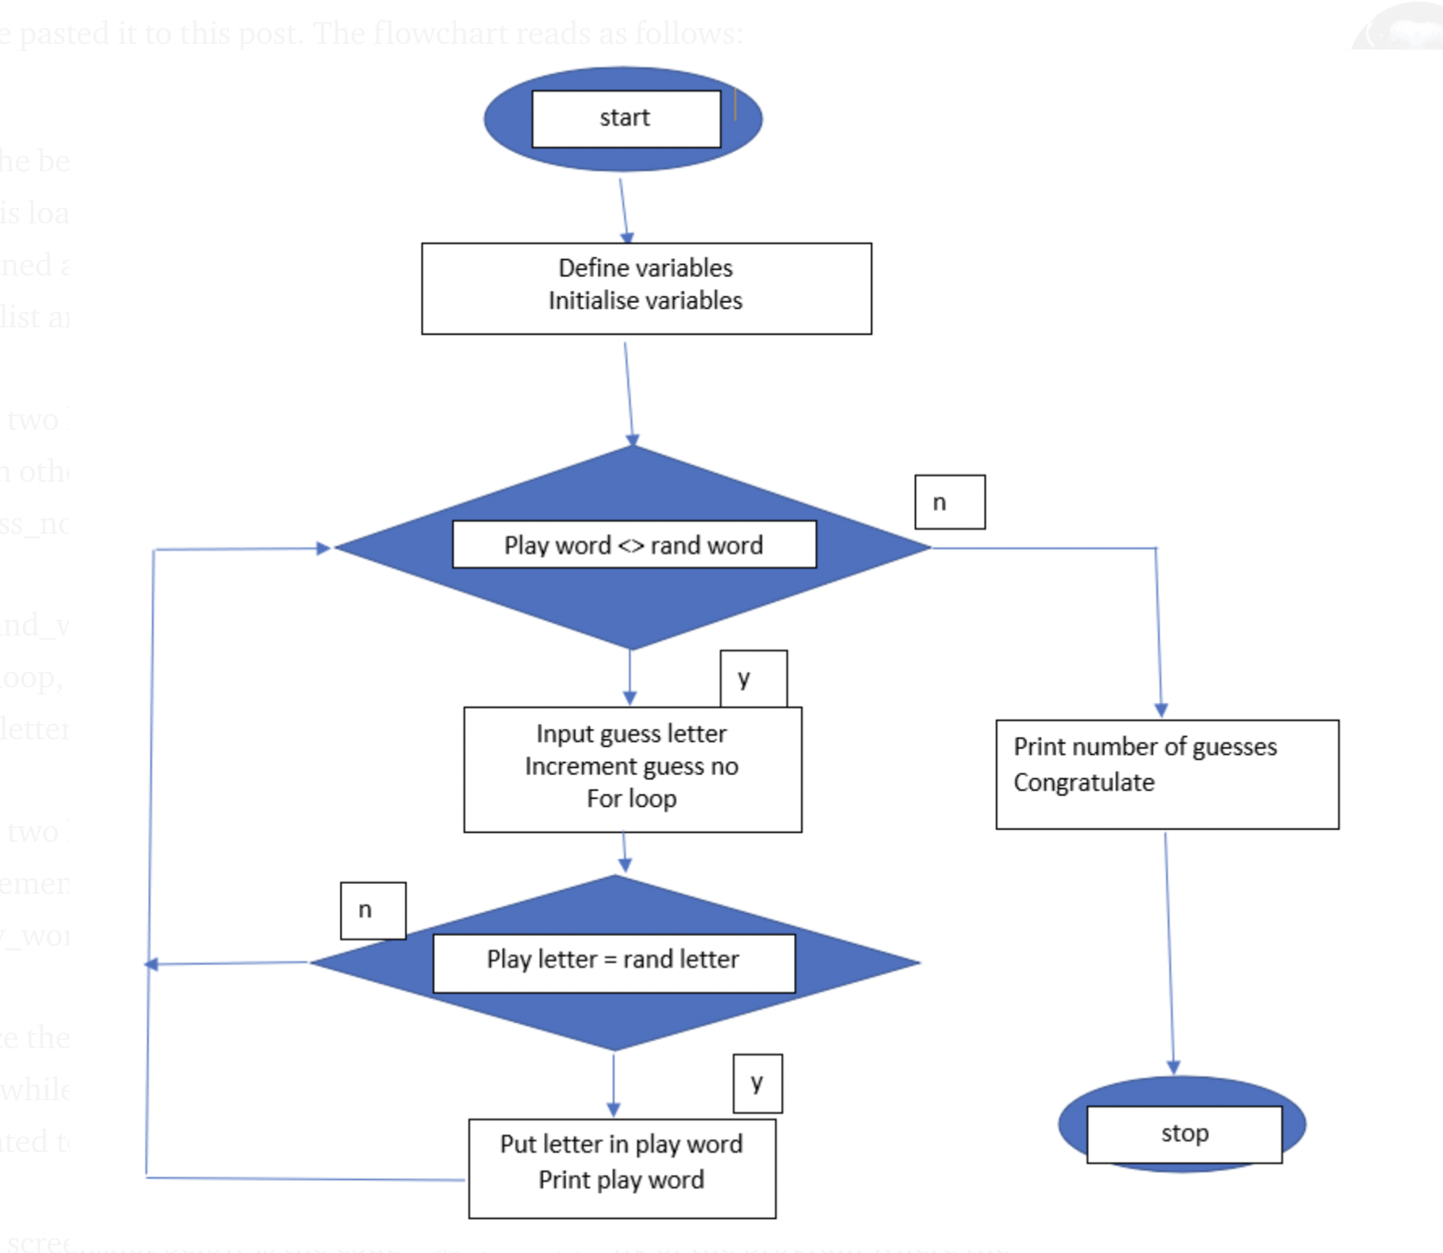

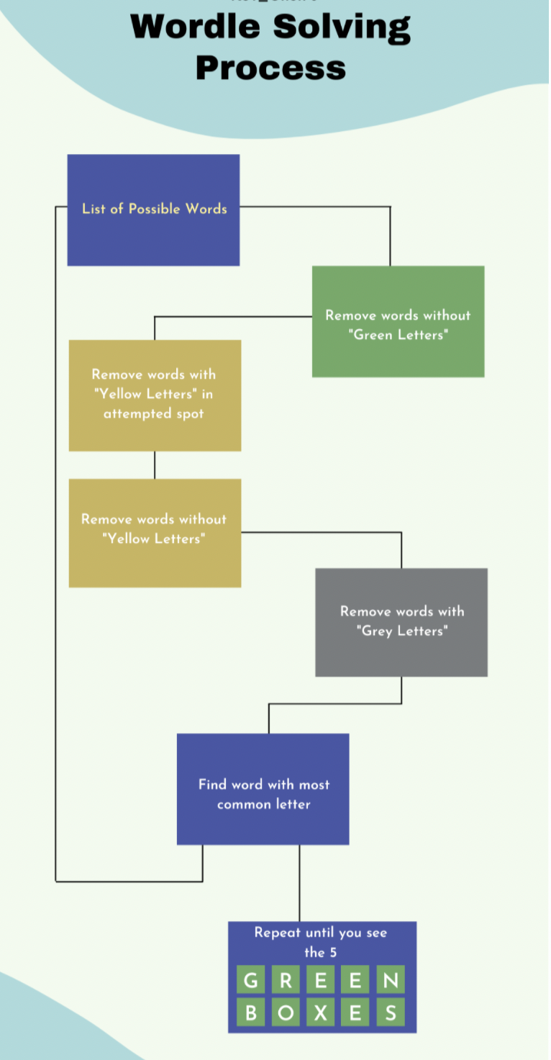

**TKINTER-Login/Registration page:**

* The Login and Registration forms are created using Python library ‘Tkinter.’
* Tkinter allows creating GUI-based applications and is rich with helpful widgets.
* For the database, we have used Sql.
* We have added validation on all the Entry Fields in the project that means it is mandatory to provide all the information. Not doing so will prompt an error message.
* Exception handlers are used to avoid breaking the program also you will see the error using a message box.
* Here is the description of widgets used in the program.

| **Widget Name** | **Widget Overview** |
| --- | --- |
| [Python Tkinter Frame](https://pythonguides.com/python-tkinter-frame/) | We have used two frames with the name **left frame** & **right frame**. they position the logging and registration page. The geometry manager used to position frames is Place. |
| [Tkinter Label](https://pythonguides.com/python-tkinter-label/) | The Label widget is used to display text on the application screen. All the text on the screen like ‘Enter Email’, ‘Enter Name’, etc are added using the Label widget. |
| [Entry widgets](https://pythonguides.com/python-tkinter-entry/) | Entry boxes provide white space to the user and the user can type the details inside it. It is one of the most important widgets used in any application. |
| [Python Tkinter Radiobutton](https://pythonguides.com/python-tkinter-radiobutton/) | Radiobutton widget is used to provide a single choice to the users. In the application. the user can choose only one gender at a time. |
| [OptionMenu](https://pythonguides.com/python-tkinter-optionmenu/) | OptionMenu is used to dis |
| [Button](https://pythonguides.com/python-tkinter-button/) | Buttons are used to perform an action when clicked. In this application, we have used two buttons with the names as Login and Register. |

Widgets used in the a

**Screenshots of game:**

The first window pops up in front of you when you open game file is Login/Register as shown below;

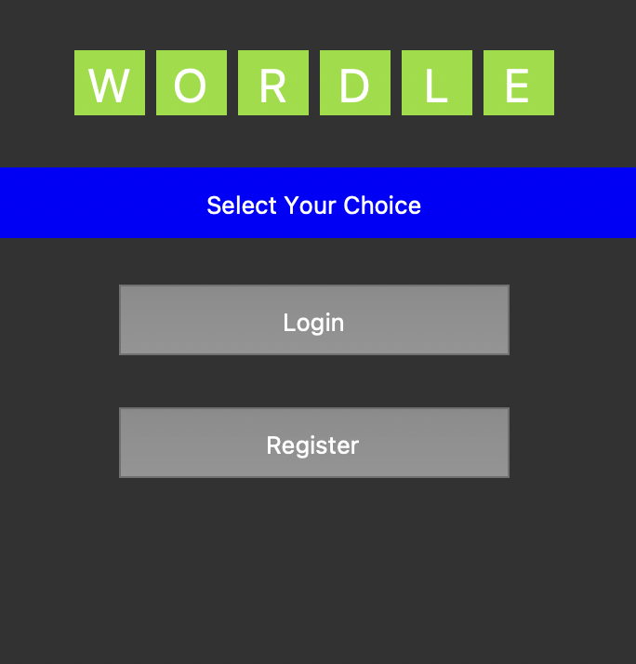

You need to register with your username, password and email id

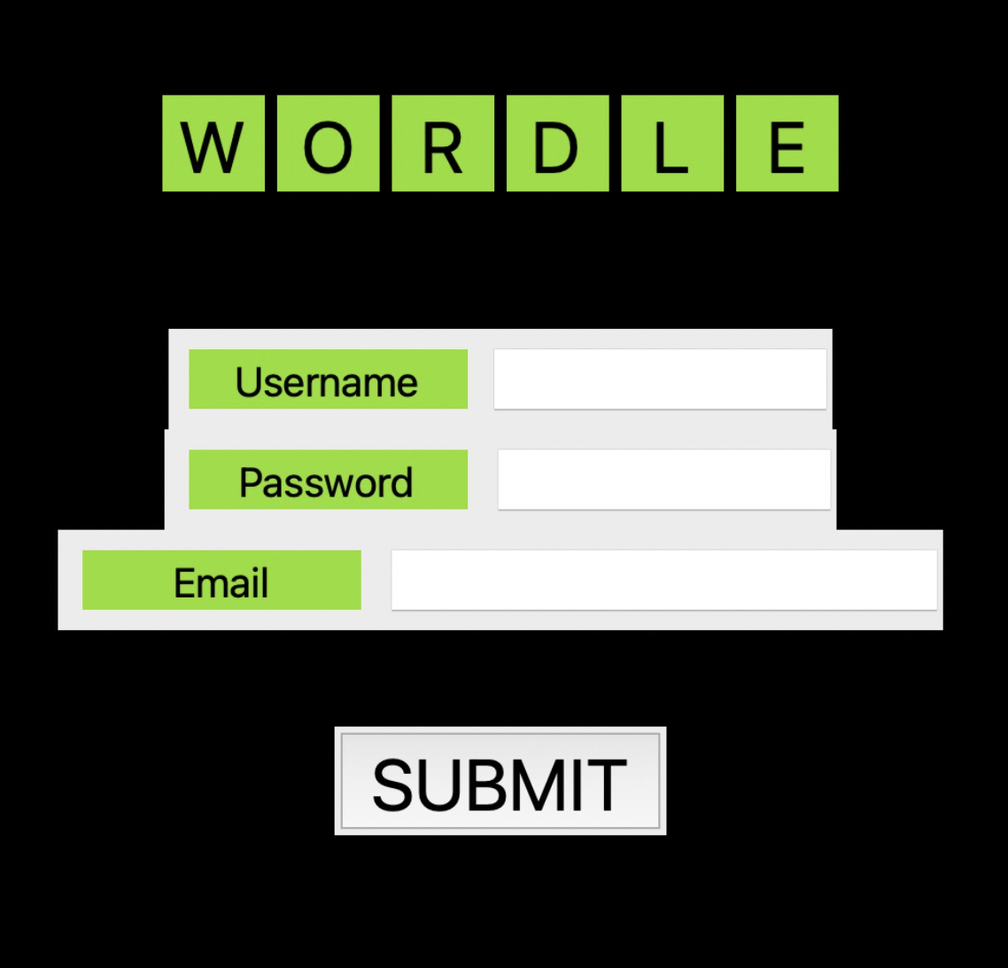

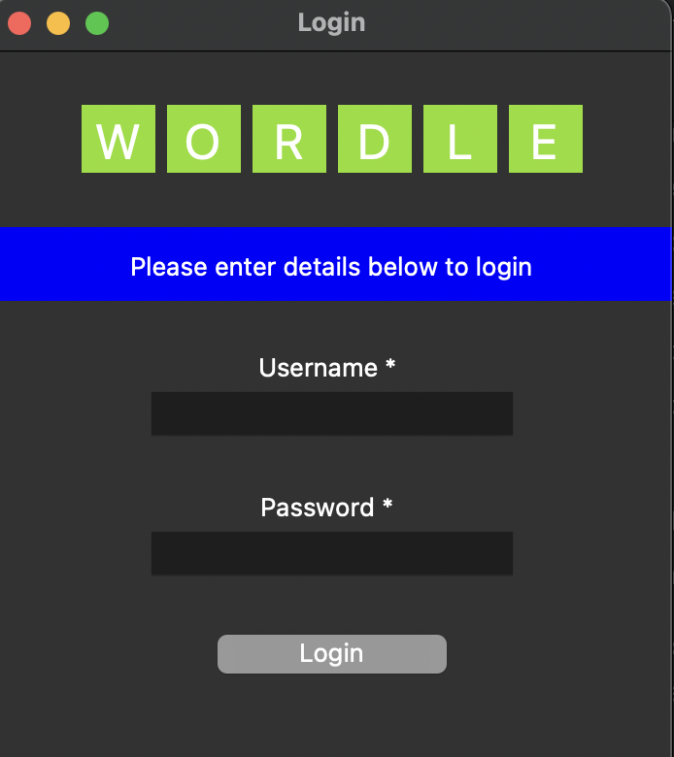

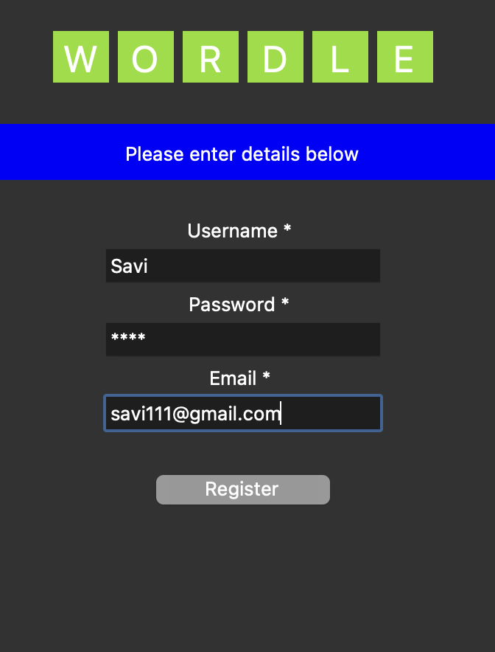

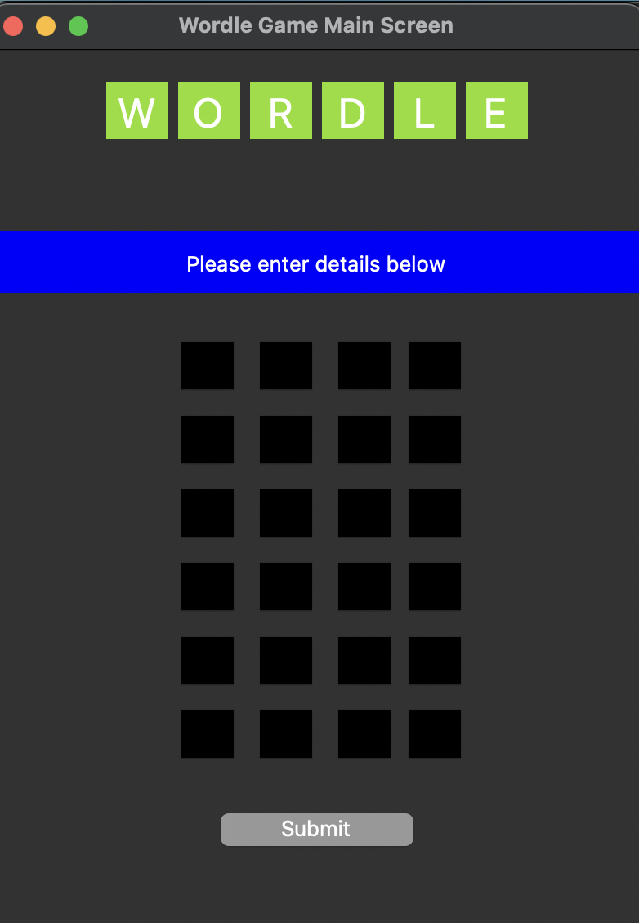

**Step by step of how to play wordle game:**

1. Start with any word of the length of box provided in a row

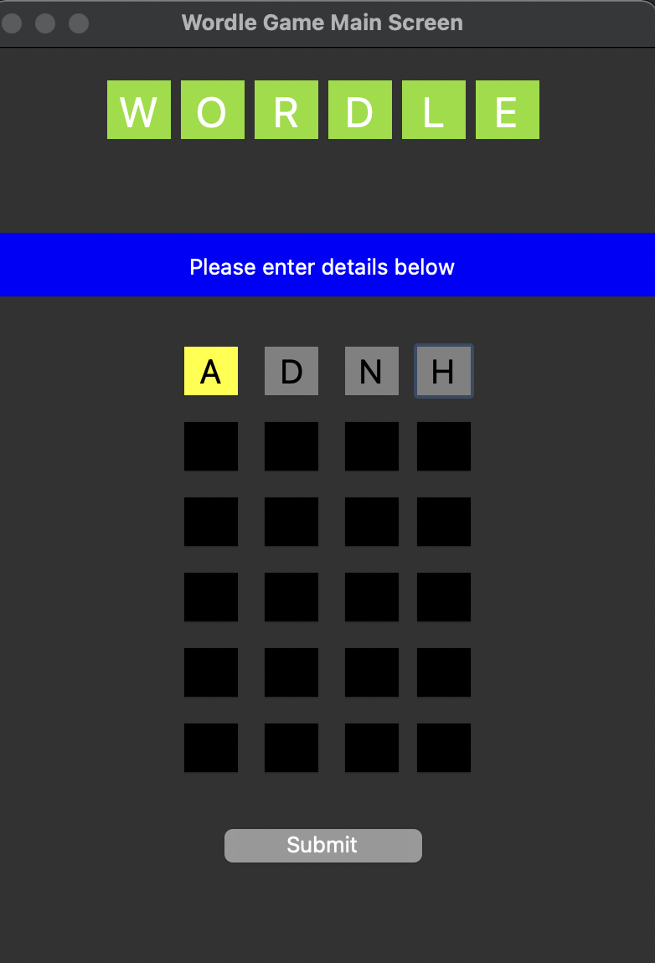

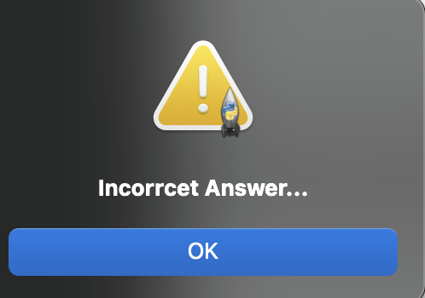

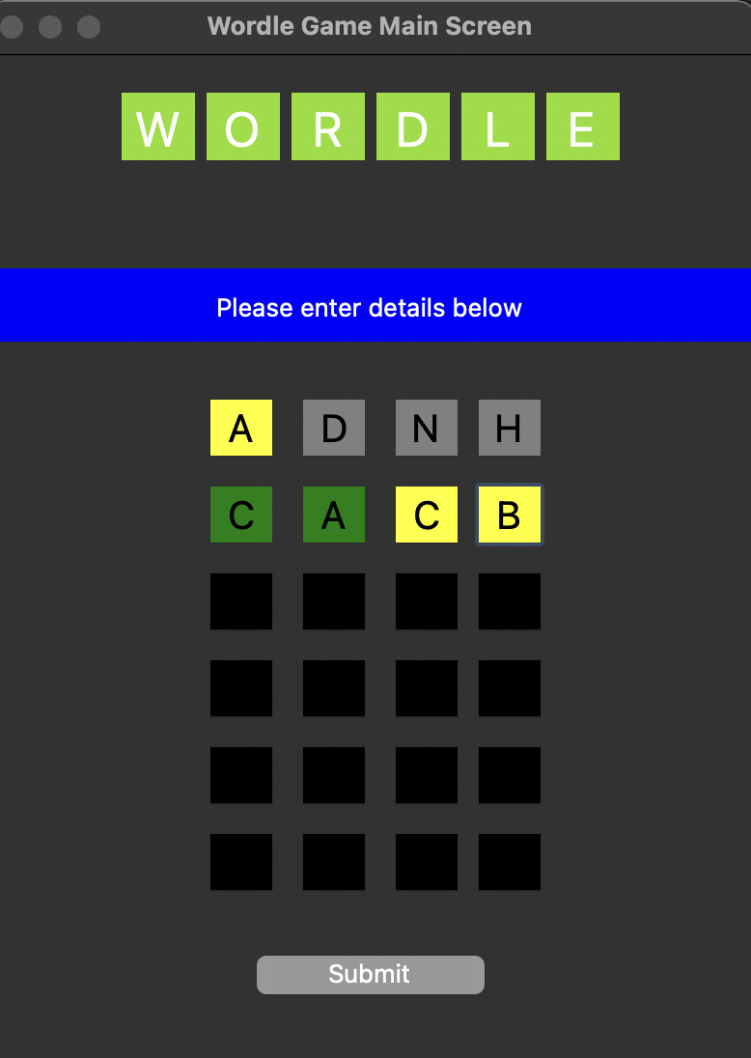



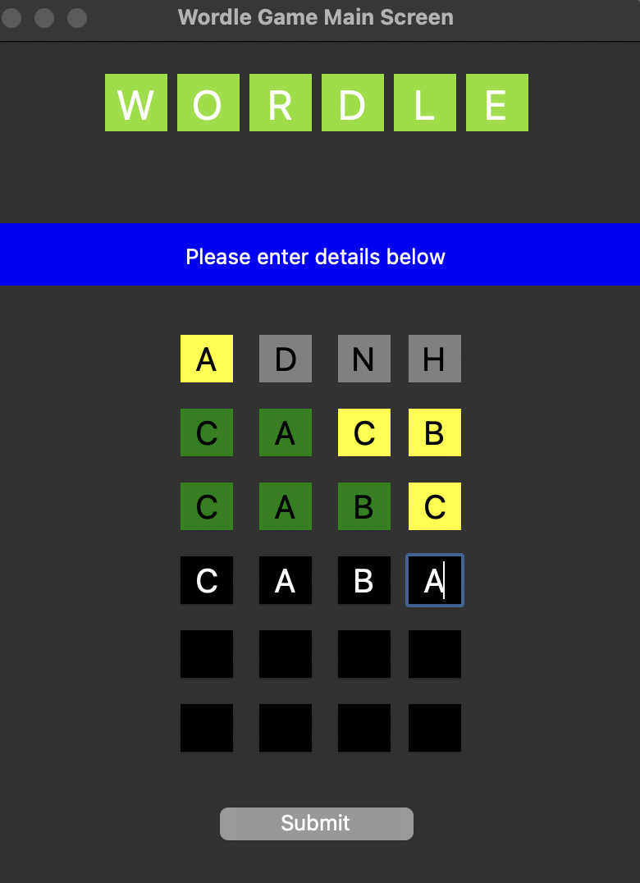

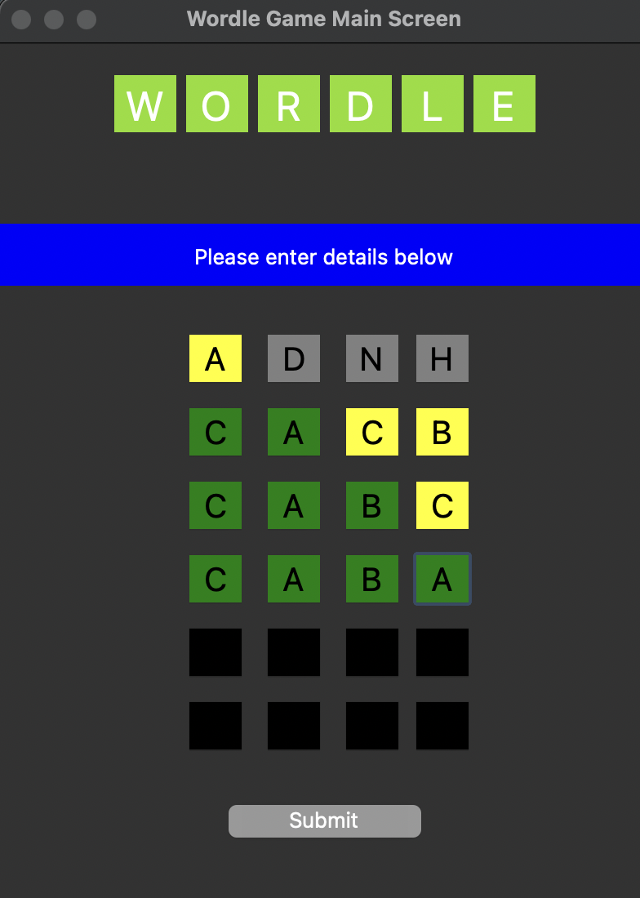

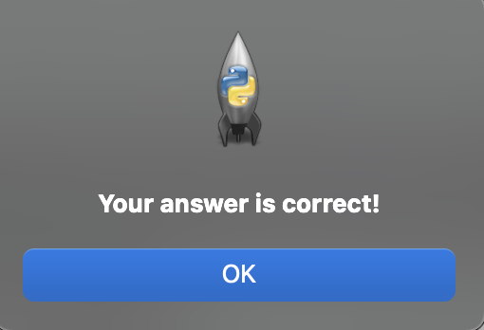

One more example of correct answer:

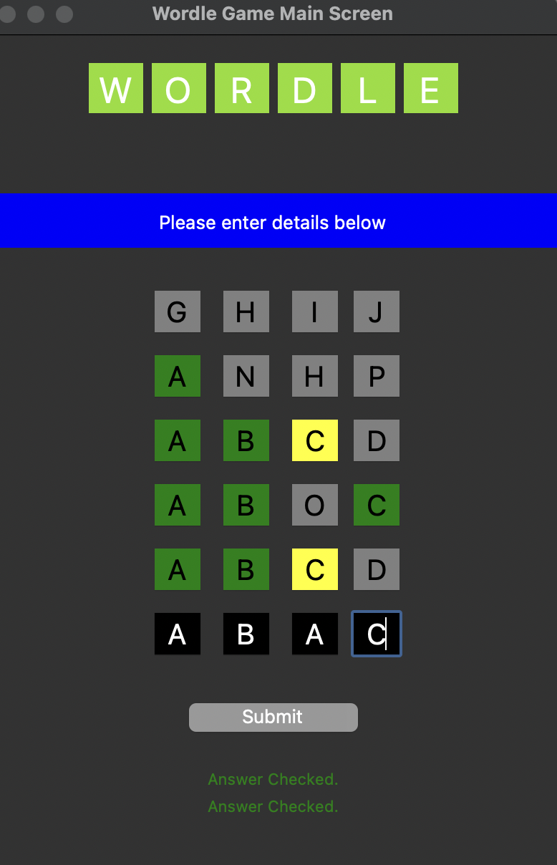



**Example when You cannot guess in 6 attempts**:

